Part 1 Technical Memo
A Longitudinal Study of County Health Insurance Coverage, 2010-2025
DATA 6700 Independent Study, Summer 2026
Seth Phillips

1. Study Overview
This memo summarizes the analytical foundation built in Weeks 2 through 5 of Part 1. The study is descriptive: it quantifies and characterizes how county-level uninsured rates changed across the United States from 2012 to 2025 and identifies which socioeconomic and demographic conditions move alongside them. It does not claim to establish cause and effect.
All code and outputs are available in the GitHub repository:
sphillips32/A-Longitudinal-Study-of-County-Health-Insurance-Coverage-2010-2025

2. Data Source and Panel Construction
The working data are 16 annual County Health Rankings (CHR) analytic CSV files, release years 2010-2025, produced by the University of Wisconsin Population Health Institute.
Primary panel: data/chr_panel.csv
- 43,873 county-year observations, release years 2012-2025
- Measure years 2009-2022: SAHIE estimates lag CHR release year by approximately two years
- 3,142 unique county FIPS codes
- Connecticut excluded due to the 2022 county-to-planning-region restructuring
- State summary rows (FIPS ending in 000) excluded throughout
- FIPS codes treated as zero-padded 5-digit strings
Key construction decisions:
- CHR CSVs have a two-row header. Row 0 is human-readable labels; row 1 is stable measure ID codes. The loader uses header=1 so pandas reads measure IDs as column names.
- The all-ages uninsured measure (v085) begins in the 2012 CHR release. The 2010-2011 releases use an adults-only measure (v003) held in a separate extension panel.
- poverty_rate (v118) was confirmed as Wisconsin-only data and dropped. child_poverty_rate (v024) is retained as the poverty proxy.
Together these construction choices produce a clean, consistently defined county-year grid: every row has a validated 5-digit FIPS code, covers a real county rather than a state total, and reports the same outcome measure back to 2012. The main caveat is the two-year lag between CHR release year and the underlying measure year, so a release-year label on a figure or table is roughly two years behind the survey period it describes. Section 4.1 uses measure year specifically for this reason.

3. Data Dictionary and Variable Reference
The panel includes 17 predictor variables plus the outcome (uninsured_raw), drawn from six underlying data sources: the Small Area Income and Poverty Estimates program (SAIPE), the American Community Survey (ACS), the Bureau of Labor Statistics (BLS), EDFacts, the Census Population Estimates program, HUD's Comprehensive Housing Affordability Strategy (CHAS) data, and the Small Area Health Insurance Estimates (SAHIE) program for the outcome. All proportion variables are stored in native units (0.00 to 1.00); figures convert to percentage points where labeled. The full variable-by-variable reference, including exact source and non-missing percentage for every variable, is in Appendix A. Thirteen of the 17 predictors are complete or nearly complete from 2012 onward (Core); four have meaningful gaps (Partial), summarized below.
Variable | Non-Missing | Gap
income_inequality | 78.4% | Absent 2012-2014, complete from 2015
hs_graduation_rate | 86.3% | Scattered gaps across years, not concentrated in a single period
severe_housing_rate | 85.7% | Absent 2012-2013, complete from 2014
pct_white | 92.8% | Absent 2012, complete from 2013
These four variables are the reason the Week 5 baseline models in Section 5 use 28,932 county-year observations rather than the full panel's 43,873. The baseline regressions require all 17 predictors to be present simultaneously, so a row is dropped if any single predictor is missing, not only the ones listed above. hs_graduation_rate accounts for most of that loss on its own: its missingness is scattered across counties and years rather than confined to the same early years as the other three partial variables, so it removes rows that would otherwise be complete. This is a sample restriction, not a data quality problem. The baseline models in Section 5 describe the subset of county-years where all 17 predictors are jointly observed, which is smaller, and very slightly different in composition, than the full panel used in Section 4.

4. Descriptive Findings

4.1 National Trend
The national population-weighted uninsured rate declined from approximately 17% in measure year 2009 to below 10% by measure year 2016, corresponding to ACA Medicaid expansion and marketplace coverage. The rate then stabilized and remained near 10% through measure year 2022. 99.7% of counties improved between measure years 2013 and 2016, with a median decline of 5.75 percentage points.
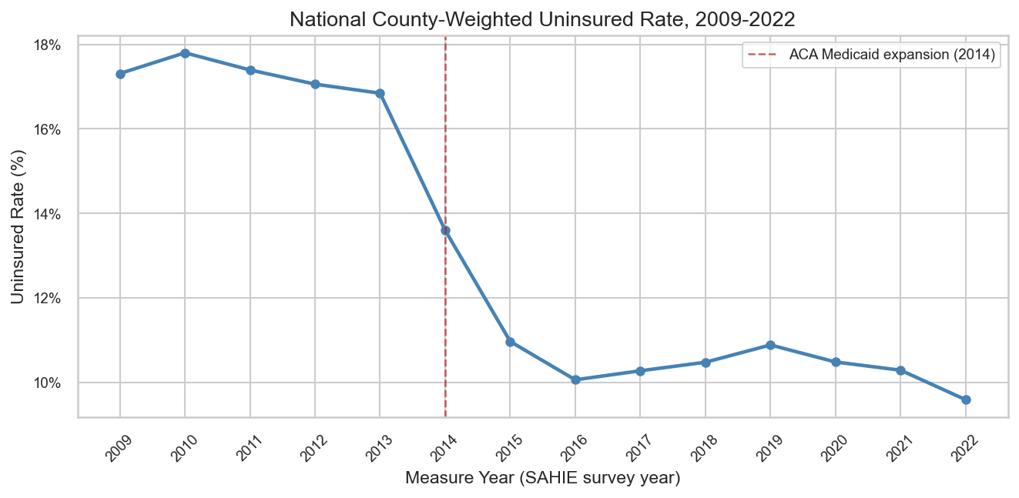
Figure 1. National population-weighted uninsured rate by measure year, 2009-2022.
Nearly all of the seven-point decline is concentrated in a three-year window, measure years 2013 to 2016, which lines up with the ACA's two main coverage levers: Medicaid expansion, effective January 2014 in most expansion states, and the federal marketplace's first open enrollment period, also 2014. The flat trend before 2013 and after 2016 is what makes this a meaningful before-and-after pattern rather than a steady long-run trend that happened to pass through this window. The main caveat is that this is a population-weighted national average: it is pulled toward the experience of large counties and says nothing yet about which places, or which kinds of counties, drove the change. That question is taken up directly in Sections 4.2 through 4.4.

4.2 Regional and State Patterns
Southern states show consistently higher median uninsured rates throughout the panel period, driven by both higher baseline rates and the concentration of non-expansion states in that region. Western states show the steepest post-2014 declines. States that expanded Medicaid in 2014 show a sharp break beginning around that year, while non-expansion states show more gradual declines without a clear inflection point.
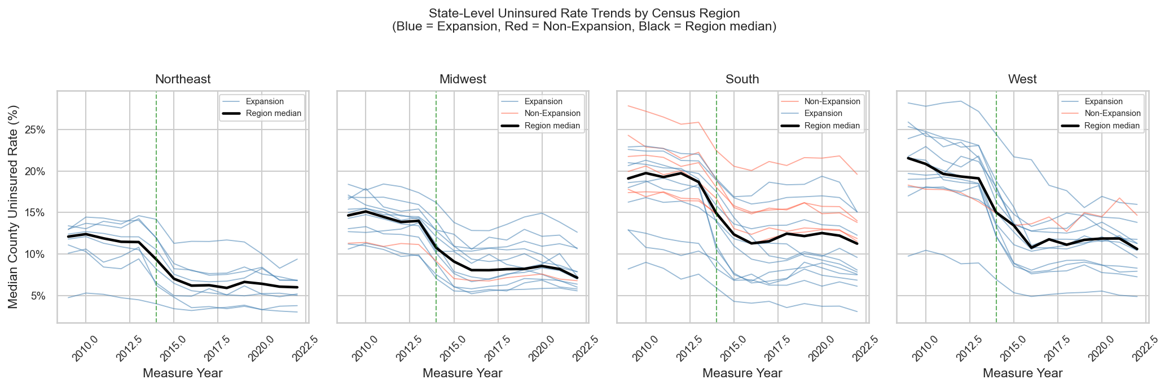
Figure 2. Uninsured rate trends by Census region, 2012-2025.
The regional gap is persistent rather than a one-time offset: the South does not simply start higher, it stays higher across the full panel, while the West's steeper post-2014 decline narrows the regional spread over time rather than widening it. This matters for the rest of the study because Medicaid expansion status is not randomly distributed across counties, it is concentrated by region and by state, so any county-level characteristic that is also regionally clustered, such as income or rurality, is a plausible confound for a naive comparison between expansion and non-expansion counties. The caveat here is that region is a coarse four-way grouping; the policy variation that actually matters is at the state level, which is why Section 4.4 compares expansion status directly rather than relying on region as a proxy.

4.3 Correlations with the Outcome
Pooled Pearson correlations across all county-years (2012-2025):
- Strongest positive: child_poverty_rate (r = 0.49), pct_hispanic (r = 0.37)
- Strongest negative: median_income (r = -0.48), some_college_rate (r = -0.48)
- unemployment_rate divergence: pooled r = 0.37 but cross-sectional r = -0.08 in 2019. This suggests unemployment captures a shared national time trend rather than a stable county-level association.
The unemployment_rate divergence is the most important pattern in this table, more important than the size of any single correlation. A positive pooled correlation alongside a near-zero or negative single-year cross-sectional correlation means the pooled number is likely driven by a shared national trend across years (unemployment and the uninsured rate both fell together over the study period, for reasons that may have little to do with each other) rather than a stable relationship between the two variables at a point in time. A purely cross-sectional or pooled analysis cannot distinguish between these two explanations, which is the main empirical reason Part 2 moves to a panel design with fixed effects rather than treating these pooled correlations as the final word. The broader caveat that applies to every correlation in this section: Pearson correlation is bivariate and unconditional, it does not hold any other variable constant, so none of these figures should be read as the isolated effect of one predictor.

4.4 Medicaid Expansion Extension
A descriptive comparison of 2014-only expansion states versus never-expanded states shows a larger and sharper decline post-2014 in expansion states. The descriptive difference-in-differences estimate is 0.93 percentage points. Pre-expansion trajectories are flat for both groups, supporting group comparability. This comparison is descriptive and does not control for other factors.
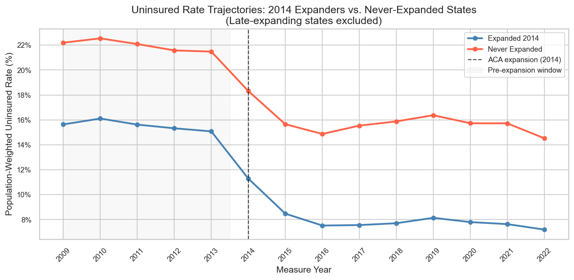
Figure 3. Uninsured rate trends, 2014-only expansion states versus never-expanded states.
The flat, overlapping pre-2014 trajectories in Figure 3 are doing real work: they are the empirical basis for treating expansion and non-expansion states as comparable before the policy change, which is the assumption a difference-in-differences comparison depends on. Without that flat pre-period, the 0.93 percentage point post-2014 gap could just as easily reflect two groups that were already on different paths. The main caveats are the small group size, only 8 states never expanded Medicaid at all, so this comparison is sensitive to which specific large states fall in each bucket, and the fact that no other county or state characteristics are held constant here. The choice of expansion flag, a fixed 2014-only indicator or a time-varying flag that accounts for later expansions, has been submitted to the professor for input and is still pending; the answer could change the size of this estimate somewhat, though it is unlikely to reverse its direction.

5. Baseline Model Results
All models use the 2015-2025 release-year window and 28,932 clean county-year observations. The outcome is the all-ages uninsured rate in proportion units. These are descriptive benchmarks, not the final analysis.
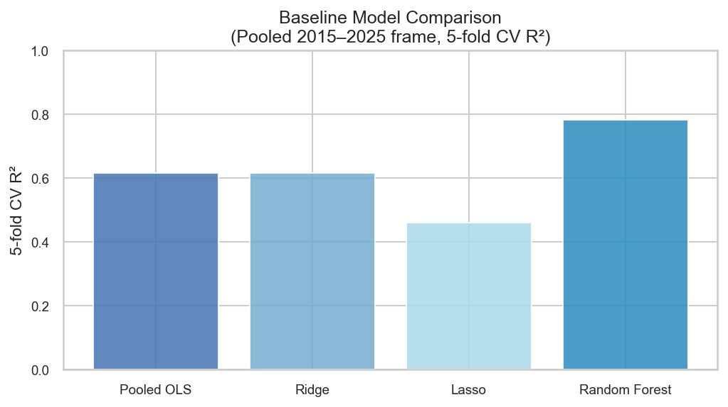
Figure 4. Cross-validated R-squared by model.
Model | CV R-squared | Notes
Pooled OLS | 0.616 | Linear benchmark with year dummies; 17 core features
Ridge | 0.616 | L2 penalty, cross-validated alpha; standardised features plus year dummies
Lasso | 0.462 | L1 penalty, cross-validated alpha; zeroed 8 of 17 features
Random Forest | 0.783 | 500 trees, cross-validated; nonlinearity and interaction check
The random forest's 0.17 R-squared advantage over the linear models means some of the relationship between these 17 predictors and the uninsured rate is nonlinear or involves interactions between predictors, which a plain linear model cannot capture no matter how the predictors are transformed individually. This matters mainly as a ceiling check: it shows how much a much more flexible model could improve on a linear one, without saying which predictors interact or how. The gap is real but modest, so a well-specified linear panel model is not expected to fail outright in Part 2, though some residual nonlinearity should be expected and is a reasonable thing to revisit later in the study.
Lasso zeroing 8 of the 17 features is a data-driven, cross-validated signal about redundancy, not about whether a variable matters to the uninsured rate on its own. unemployment_rate being zeroed lines up with its Section 4.3 correlation behavior: a variable whose pooled correlation is driven mostly by a shared time trend is also a variable lasso can often reconstruct from the year dummies already in the model, making its own coefficient less necessary. The demographic share variables being zeroed is a caveat as much as a finding: these variables are highly collinear with each other, since they are shares of the same population and move together, so lasso's choice of which one to zero out can be somewhat arbitrary and sensitive to small changes in the data. A zeroed coefficient here means redundant given the other predictors in this specific model, not unrelated to coverage.
The swing in the pct_white coefficient, from -1.15 under OLS to -0.06 under ridge, a 94% reduction, is the clearest evidence in this section of an unstable OLS estimate. Because ridge and OLS agree on so little for this variable, neither number should be read as the effect of pct_white; the instability itself is the finding, and it is a direct consequence of the multicollinearity among the demographic share variables that lasso also picked up on independently. The caveat that applies to ridge specifically: its coefficients are biased by design, that bias is the mechanism that produces the smaller, more stable estimate, so ridge is a diagnostic for instability here, not a replacement estimate to report as final.

6. Variable Carry-Forward Decisions for Part 2
The carry-forward table combines lasso active/inactive status with random forest importance rank. Features are evaluated on both signals together.
Feature | Lasso Active | RF Rank | Decision
child_poverty_rate | Yes | 1 | Strong carry-forward
pct_hispanic | Yes | 2 | Strong carry-forward
pct_aian | Yes | 3 | Strong carry-forward
median_income | Yes | 4 | Strong carry-forward
some_college_rate | Yes | 5 | Strong carry-forward
pct_asian | No | 6 | Redundant given other demographic shares
pct_white | Yes | 7 | Strong carry-forward
hs_graduation_rate | No | 8 | Dropped: scattered missingness
pct_65plus | No | 9 | Redundant given other demographic shares
pct_under18 | Yes | 10 | Strong carry-forward
unemployment_rate | No | 11 | Redundant given year dummies
pct_black | No | 12 | Redundant given other demographic shares
pct_rural | Yes | 13 | Strong carry-forward
population | No | 14 | Redundant given other predictors
income_inequality | No | 15 | Dropped: partial availability
severe_housing_rate | Yes | 16 | Strong carry-forward
single_parent_rate | No | 17 | Redundant given other predictors

Appendix A: Full Variable Reference and Availability
Combined data dictionary and missingness detail for all 17 predictors and the outcome. See Section 3 for the summary version and the interpretation of the sample-size gap this creates for the Section 5 baseline models.
Variable | Description | Source | Group | Non-Missing | Notes
uninsured_raw | All-ages uninsured rate (proportion) | SAHIE | Outcome | 100% | All 14 release years
median_income | Median household income (dollars) | SAIPE | Core | 99.9% | Complete from 2012
child_poverty_rate | Proportion of children in poverty | SAIPE | Core | 99.9% | Complete from 2012; poverty proxy
income_inequality | 80th/20th income ratio | ACS | Partial | 78.4% | Absent 2012-2014, complete from 2015
unemployment_rate | Proportion of labor force unemployed | BLS | Core | 99.9% | Complete from 2012
hs_graduation_rate | 4-year high school graduation rate | EDFacts | Partial | 86.3% | Scattered gaps across years
some_college_rate | Proportion of adults with some college or degree | ACS | Core | 100% | Complete from 2012
single_parent_rate | Proportion of households with single parent | ACS | Core | 99.9% | Complete from 2012
severe_housing_rate | Proportion with severe housing problems | HUD CHAS | Partial | 85.7% | Absent 2012-2013, complete from 2014
pct_rural | Proportion in rural areas | Census | Core | 99.9% | Complete from 2012
pct_under18 | Proportion under age 18 | Census | Core | 100% | Complete from 2012
pct_65plus | Proportion age 65 and older | Census | Core | 100% | Complete from 2012
pct_black | Proportion non-Hispanic Black | Census | Core | 100% | Complete from 2012
pct_aian | Proportion American Indian or Alaska Native | Census | Core | 100% | Complete from 2012
pct_asian | Proportion Asian | Census | Core | 100% | Complete from 2012
pct_hispanic | Proportion Hispanic | Census | Core | 100% | Complete from 2012
pct_white | Proportion non-Hispanic White | Census | Partial | 92.8% | Absent 2012, complete from 2013
population | Total county population | Census | Core | 100% | Complete from 2012

